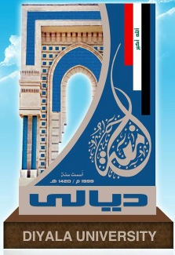
Ministry of Higher Education and Scientific Research - Diyala University College of Agriculture / Department of Animal Production
Curriculum Vitae of a faculty member

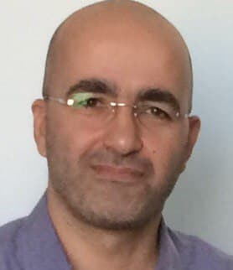
First: Personal Information
07704532392 | Phone Number | Ahmed Sinan Ahmed | Full name
ahmedsinan@uodiyala.edu.iq | Email Address | 1976 | DOB
Assis. Prof. | Scientific Title | PhD degree | Certificate

Personal Image

Second: Scientific Activities: Master's and Doctoral Degrees
Effect of fasting and addition of ammonium chloride, sodium bicarbonate with drinking water on productive and physical performance of broiler under high temperature | Title of Master Thesis
Effect of Different Sources and levels of Chromium Supplementation to Awassi Lambs Rations on Carcass Quantity and Quality Characteristics | Title of Doctor Thesis

Third: Administrative Tasks

Period | The Administrative Tasks Assigned to You | No.
11/1/2017 | Director, Laboratory of Nutrition | 1
Fourth: Number of Committees in Which You Participated :
The Most Important of which:
- Purchases Committee
- Educational Committee for Student Affairs
- Committee of Istlal Research Promotion to Assistant Professor
- Examinations Committee
- Research Committee for students of the fourth stage
- Examinations Committee
- Educational Committee for Student Affairs
- Self-Assessment Report Committee
- Price Determination Committee
- Research Committee upgrade .
- Educational Committee for Student Affairs.
- Self-Assessment Report Committee.

Fifth: Member's Participation of the University and Community Service

Period | Participation Type | Participation Name | No.
2011 | Preparatory Committee | Preparation of the First National Conference on Agricultural Research Diyala university- Diyala | 1
2014 | participant | Scientific symposium in the Department of Animal Wealth entitled visions in improving the reality of local sheep- Diyala | 2
2016 | participant | Symposium on the obstacles of raising ruminants in Diyala - Diseases - Fodder – Breeds- Diyala | 3
2015 | participant | The Fifth Scientific Conference of the Poultry Science Society- Diyala | 4
2019 | participant | The Fourth International Conference on Agricultural Sciences (ICAS) Karbala University | 5
2021 | participant | The Fourth International Conference on Pure and Agricultural Sciences (ICPAS) Kirkuk University | 6
Sixth: Published and Accepted Researches
1- The importance of adding NHCl, NaHCO3 to drinking water and fasting for broilers exposed to high environmental temperatures and its effect on the host performance.
2-Supplying drinking water with ammonium chloride and sodium bicarbonate salts before exposure to heat stress and fasting during the heat stress period on the productive performance of male Faubro broilers.
3-The use of ammonium chloride and sodium bicarbonate before exposure to heat stress and fasting as a means to relieve heat stress in broilers
4-Effect of feed additives of different sources of chromium to the diets of Awassi lambs on the productive and some quantitative characteristics of meat.
5-Effect of adding different sources of chromium to the diets of Awassi lambs on the productive characteristics and some quantitative characteristics of the meat produced from their carcasses.
6-The effect of using different sources of chromium as food additives on some qualitative characteristics of Awassi lambs
7- Effect of Dietary Replacement of Barley with Mushroom Cultivation Spent on Carcass Characteristics of Awassi Lambs
8- Effect of Using Different Levels of Mushroom Cultivation Spent in AWASSI Lambs Rations on Some Productive Traits
9-Effect of using Different Levels of Commercial Saccharomyces cervisiae in the Ration on Some Productive Traits of Awassi Lambs
10-Effect of Feeding Panicum mombasa Grass on Productive Traits and Carcass Characteristics of Local Cross Breed Goat
11-Effect of Different Levels of Commercial Saccharomyces cerevisiae with the Ration on Some Carcass Characteristics of Awassi Lambs
12-Effect of Testosterone Enanthate Injection on Some Carcass Traits and Chemical Characteristics of Castrated Karadi Lambs Meat
13-Some carcass traits and meat chemical characteristics of karadi lambs injected with testosterone enanthate
14- Characteristics of Awassi Lambs Carcass and Meat with Drenching of Sage, Clove and Laurel Oils
15- Preservative Effects of Gynura Procumbens Powder Used with Broiler Ration on Their Frozen Meat Stored for Different Periods
16-Effect of adding Spirulina platensis on physiochemical properties of frozen ground beef
17- Effect of adding propolis to improve the quality of frozen ground beef

Seventh: Curriculum Taught

Stage | Subject/ Course Name | No.
fourth | Meat production | 1
fourth | Meat science | 2

Ninth: Membership in Scientific Associations
Membership Type | Association Headquarters | Association Name | No.
member | Baghdad | University Teaching Association | 1
member | Baghdad | Animal Production Association | 2
member | Baghdad | Agricultural Engineers Association | 3
member | Baghdad | Rural Baghdad Association for Beekeepers | 4

